**The Power of Metadata: Structural Topic Modelling for Bibliometric Studies in Technology and Innovation Management**

Topical bibliometric studies within the Technology and Innovation Management research area

Danie Ungerer

u29129398

Abstract

Table of Contents

2 Introduction 2-1

3 Methods and Data 3-1

3.1 Bibliometric Analysis 3-1

3.2 Topic Modelling on Structural 3-1

3.3 Data 3-1

4 Results 4-1

5 Discussion 5-1

6 Conclusion 6-1

# Introduction

# Methods and Data

## Bibliometric Analysis

## Structural Topic Modelling

## Data

# Results

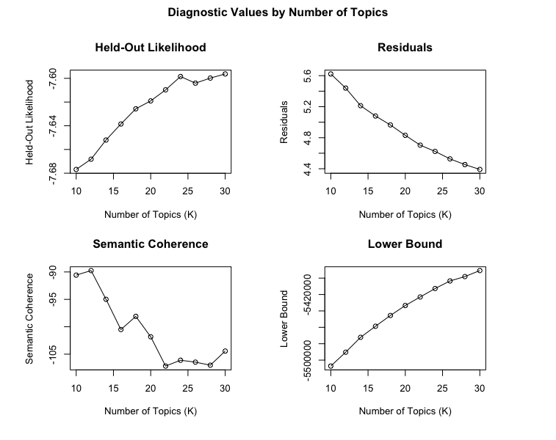

Topic Numbers to consider: c(22, 24, 26, 28)

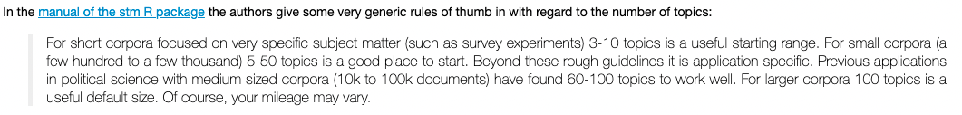

Choose Mod24

Each topic has no relation or very little relation with several documents – perhaps just take a closer look at Topic 2, 7 and 8.

We see here that document 22 is strongly associated with topic 15 and document 26 with topic 9, whereas documents 11 or 21 are more mixed



Topic 1 Top Words:

Highest Prob: manufacturing, quality, supply, management, chain, control, production, industry, process, performance

FREX: chain, supply, supplier, manufacturing, automotive, lean, audit, tqm, quality, control

Lift: (tqm), metals,, qfd, chain, tqm, (sscm), chains., oem, scm, audit

Score: supply, chain, manufacturing, quality, control, tqm, supplier, lean, automotive, production

Topic 2 Top Words:

Highest Prob: business, management, knowledge, strategic, competitive, value, model, organizational, corporate, strategy

FREX: business, corporate, competitive, knowledge, advantage, strategic, organization., value, company's, global.

Lift: fachmedien, hypercompetitive, logically, options-based, basically,, csr, managed,, organizations:, scorecard, define,

Score: business, knowledge, competitive, strategic, corporate, organizational, companies, value, organizations, chapter

Topic 3 Top Words:

Highest Prob: digital, data, technologies, smart, big, platform, 2020, new, transformation, intelligence

FREX: digital, 4.0, blockchain, big, smart, digitalization, analytics, artificial, platform, platforms

Lift: 4.0, analytics., digital, ai-based, blockchain, digitalized, iot, retailing, retailing,, retailing.

Score: digital, smart, big, blockchain, data, 4.0, analytics, platform, retail, digitalization

Topic 4 Top Words:

Highest Prob: innovative, development, economic, management, main, research, article, activity, innovations, analysis

FREX: russian, activity, innovative, economy, formation, regional, economic, competitiveness, indicators, activity.

Lift: expediency, federation,, kazakhstan,, russias, sphere,, czech, sphere, kazakhstan, kazakhstan., russian

Score: russian, innovative, economic, economy, russia, regional, activity, oil, innovation, competitiveness

Topic 5 Top Words:

Highest Prob: management, system, construction, enterprise, development, based, paper, technology, model, technology,

FREX: construction, forward, enterprise, algorithm, trans, mode, licence, iop, puts, e-commerce

Lift: buildings., countermeasure, perfecting, (2014), gray, jiangsu, supervision, trans, haier, (2013)

Score: construction, enterprise, system, trans, chinese, china, fuzzy, iop, algorithm, china's

Topic 6 Top Words:

Highest Prob: industry, rights, will, reserved., new, companies, many, challenges, international, one

FREX: book, property, japanese, intellectual, outsourcing, conference, biotechnology, examples, rights, reserved.

Lift: 1994, book,, elsewhere, industry-wide, 26th, 27th, x.0, invaluable, e-business,, handbook

Score: book, intellectual, japanese, companies, property, industry, rights, reserved., biotechnology, indian

Topic 7 Top Words:

Highest Prob: project, process, projects, implementation, management, approach, decision, model, tools, evaluation

FREX: project, projects, projects., risk, projects,, project., phase, tools, tool, decision

Lift: ppm, eco-innovation, gazprom, external,, (erp), eco-innovation., projects., integer, harmonization, checklists

Score: project, projects, projects., eco-innovation, software, process, risk, evaluation, decision, project.

Topic 8 Top Words:

Highest Prob: innovation, innovation., management, open, innovation,, paper, process, innovations, ltd., companies

FREX: innovation., innovation, open, radical, innovation,, innovations., incremental, inderscience, innovate, innovating

Lift: (ri), rri, imm, discontinuity, communicative, oi., innovation', innovation., champions, radical

Score: innovation, open, innovation., radical, innovation,, innovations, incremental, companies, ambidexterity, openness

Topic 9 Top Words:

Highest Prob: health, medical, healthcare, clinical, technology, management, care, equipment, engineering, maintenance

FREX: health, medical, healthcare, clinical, care, hospital, hospitals, patient, biomedical, patients

Lift: (htm)., biomed, chronic, clinical,, clinics, diseases., doctors,, hospitals, lippincott, nurse

Score: health, medical, clinical, healthcare, care, hospitals, hospital, patient, biomedical, patients

Topic 10 Top Words:

Highest Prob: power, brazilian, tourism, management, electric, sector, development, safety, nuclear, model

FREX: brazilian, tourism, nuclear, power, grid, brazil, regulation, electric, brazil., (ii)

Lift: (brazilian, las, aisti., artculo, grid., innovacin, nuclear, ocean, para, que

Score: power, tourism, brazilian, nuclear, electric, electricity, grid, wind, para, brazil

Topic 11 Top Words:

Highest Prob: information, service, services, communication, use, systems, security, ict, new, mobile

FREX: ict, service, information, logistics, security, electronic, rfid, services, banking, communication

Lift: multimodal, portal, rfid, ict, libraries, libraries., port, banks, portals, librarians

Score: service, information, cloud, services, logistics, mobile, security, ict, rfid, banking

Topic 12 Top Words:

Highest Prob: product, new, development, products, market, design, customer, marketing, companies, customers

FREX: product, npd, brand, products, customers, products., disruptive, front, marketing, (npd)

Lift: design-driven, npd., (npd), (pss), case-study, euro-australian, product's, lego, pss, npd,

Score: product, npd, products, customer, customers, brand, disruptive, market, design, (npd)

Topic 13 Top Words:

Highest Prob: research, management, literature, review, analysis, field, academic, management,, scientific, future

FREX: articles, papers, journals, journal, bibliometric, review, topic, text, research., topics

Lift: alberto, anniversary, articles., bibliometric, budapest,, citation-based, citespace, co-citation, counts, dirichlet

Score: journals, articles, papers, bibliometric, literature, citation, review, jpim, journal, academic

Topic 14 Top Words:

Highest Prob: firms, firm, performance, study, relationship, performance., capabilities, capability, management, effect

FREX: firm, firms, firms., performance., smes, firm's, firms,, capability, firms', capabilities

Lift: curvilinear, fuzzy-set, moderating, slack, (pls-sem), subsidiaries., taiwanese, returns., smes', moderates

Score: firms, firm, performance., smes, firms., firm's, capability, family, absorptive, moderating

Topic 15 Top Words:

Highest Prob: food, management, water, production, agricultural, rural, systems, use, productivity, group

FREX: food, agricultural, farmers, agriculture, soil, rural, water, yield, aquaculture, rice

Lift: css, dry, farmers, farms., necessity,, 11:, agricultural, breeding, cattle, civilian

Score: water, agricultural, food, farmers, soil, rural, agriculture, rice, coal, aquaculture

Topic 16 Top Words:

Highest Prob: research, paper, framework, study, purpose, practical, publishing, literature, model, case

FREX: originality/value:, design/methodology/approach:, emerald, limited., purpose:, findings:, implications:, purpose, publishing, practical

Lift: design/methodology/approach, originality/value, shortcomings,, design/methodology/approach:, limitations/implications, limitations/implications:, originality/value:, multi-attribute, intuition, implications:

Score: emerald, originality/value:, design/methodology/approach:, findings:, purpose:, limited., implications:, limitations/implications:, originality/value, literature

Topic 17 Top Words:

Highest Prob: study, results, data, factors, analysis, using, research, used, survey, patent

FREX: patent, patents, questionnaire, variables, collected, showed, survey, statistical, regression, correlation

Lift: average,, regression,, chi-square, gender,, intention., patent., tam, (tam),, spss, finding:

Score: patent, patents, questionnaire, data, variables, regression, survey, collected, factors, companies

Topic 18 Top Words:

Highest Prob: technology, technological, management, technologies, development, paper, strategic, technology., transfer, can

FREX: roadmapping, technology, technological, convergence, transfer, technology., roadmap, roadmaps, acquisition, technologies.

Lift: (stm), (trl), roadmap., roadmapping, stm, roadmapping,, roadmapping., trls, (trm), roadmaps

Score: technology, technological, roadmapping, technologies, transfer, strategic, roadmaps, roadmap, convergence, technologies.

Topic 19 Top Words:

Highest Prob: policy, r&d, public, countries, national, developing, paper, economic, government, global

FREX: countries, trading, countries., economies, policy, foreign, francis, policies, informa, limited,

Lift: fdi, finland,, fdi,, (fdi), trading, country-specific, industrialised, latecomer, informa, asian

Score: countries, policy, r&d, foreign, national, francis, fdi, government, taylor, chinese

Topic 20 Top Words:

Highest Prob: learning, engineering, education, university, students, management, design, program, teaching, educational

FREX: students, teaching, courses, students., education, faculty, student, course, curriculum, educational

Lift: e-learning, wiki, (pbl), 20+, bachelor, curricula,, curricular, didactic, elearning, faculty.

Score: students, education, teaching, learning, engineering, educational, courses, helicopter, curriculum, student

Topic 21 Top Words:

Highest Prob: sustainable, energy, environmental, sustainability, green, can, development, gas, renewable, oil

FREX: carbon, nanotechnology, green, renewable, sustainability, energy, emissions, environmental, co2, sustainable

Lift: carbon, chemicals, diesel, dioxide, emissions, emissions., fuel., fuels, gas,, gases

Score: energy, environmental, green, sustainable, renewable, sustainability, carbon, gas, fuel, co2

Topic 22 Top Words:

Highest Prob: research, organizational, knowledge, collaboration, ideas, creative, work, leadership, team, creativity

FREX: creativity, creative, leadership, entrepreneurial, employees, team, teams, employee, collective, collaboration

Lift: crowdfunding, individual-level, members', teamwork, incubator, creativity., styles,, bmi, twofold., employee-driven

Score: creativity, creative, organizational, team, entrepreneurship, entrepreneurial, leadership, collaboration, ideas, employees

Topic 23 Top Words:

Highest Prob: social, diffusion, media, may, can, uncertainty, potential, adoption, within, wiley

FREX: diffusion, john, media, wiley, social, uncertainty, sons, heart, attitudes, sons,

Lift: (cpb), aorta, cannulation, cpb,, female., mortality, myocardial, usa), atrial, cardiac

Score: social, media, diffusion, wiley, john, extracorporeal, cpb, sons, mortality, uncertainty

Topic 24 Top Words:

Highest Prob: network, networks, collaborative, management, system, ieee., can, based, systems, access

FREX: network, networks, networks., distributed, collaborative, networks,, virtual, 2003, adaptive, web

Lift: ethernet, gigabit, ietf, network-wide, qos, corba, mpls, networks., standardization., topology

Score: network, networks, collaborative, networks., wireless, virtual, web, architecture, distributed, mobile

Better way to approximate each topic (Title, Abstract, Keywords)

Next steps:

1. 13 September – topic annotation submission (time series chart)
2. 20 September – 1st complete manuscript submission

# Discussion

# Conclusion